P2 重难点针对性练习题(金属)

1.了解所有金属的共性:
物理性质：1. High melting point; 2. Great electric conductivity
3. malleable and ductile (延展性) 4. Great thermal conductivity 5. Strong
化学性质：Metallic (金属性) ：The ability of a particle to lose electrons
1. React with water: Ca(s) + 2 H₂O(l) → Ca(OH)₂ (aq) + H₂(g)
2. React with dilute hydrochloric acid :Mg(s) + HCl(aq) → MgCl₂ (aq) + H₂(g)
3. React rigorously with oxygen : 4 Li + O₂ → 2 Li₂O
4. Form basic oxide
1. A substance, X, has the following properties.
1 It has a high melting point.
2 It conducts electricity in the solid and liquid states.
3 It is malleable. 4 It had a high density.
What is X? （ ）
A a ceramic B copper C graphite D sodium chloride

2. Which property is not considered a typical metallic property? （ ）
A good conductor of heat
B low melting point
C malleable (can be hammered into shape)
D strong

3. Which element is a metal? （ ）
 | charge on element ion | electrical conductivity
A | negative | low
B | positive | high
C | negative | high
D | positive | low

4. What is the balanced chemical equation for reaction between calcium and water? （ ）
A $Ca+H_{2}O→CaOH+H_{2}$
B $Ca+H_{2}O→Ca(OH)_{2}+H_{2}$
C $Ca+2H_{2}O→CaOH+H_{2}$
D $Ca+2H_{2}O→Ca(OH)_{2}+H_{2}$
5. The following statements are made about the metals copper, iron, magnesium and zinc.
1 Their oxides are acidic.
2 They all conduct electricity in the solid state.
3 They all have high melting points.
4 They all react with dilute acids to form hydrogen.
Which statements are correct? （ ）
A 1 and 2 B 1 and 4 C 2 and 3 D 3 and 4

6. Three students, X, Y and Z, were told that solid P reacts with dilute acids and also conducts electricity.
The table shows the students suggestions about the identity of P.
X | Y | Z
copper | iron | graphite
Which of the students are correct? （ ）
A X, Y and Z B X only C Y only D Z only

二.区分main group metal 与 transition metal的性质差异
了解main group metal (以Alkali metal微粒) 的物理性质和化学性质(metallic)
Alkali metal ：GroupⅠ elements
物理性质：
1. Soft ( can be cut easily) 2. Lighter than most metal 3.Low melting point
化学性质：Metallic (金属性) ：The ability of a particle to lose electrons
1. React rigorously with water: 2 Li + 2 H₂O → 2 LiOH + H₂
2. React rigorously with Chlorine : 2 Li + Cl₂ → 2 LiCl₂
3. React rigorously with oxygen : 4 Li + O₂ → 2 Li₂O
Transition metal的性质：
1. High density 2. High melting point 3. Form coloured compounds
4. Having ions of variable oxidation number
用途：Act as catalyst as elements and compounds
1. What is not a property of Group I metals? （ ）
A They are soft and can be cut with a knife.
B They react when exposed to oxygen in the air.
C They produce an acidic solution when they react with water.
D They react rapidly with water producing hydrogen gas.

2. Group I metal are also known as the Alkali Metals.
Which statement about the metals in Group I is not correct? （ ）
A In their reactions they lose electrons.
B Their atoms all have one electron in their outer shell.
C They form $+1$ ions in their reactions with non- metals.
D They form covalent compounds by sharing electrons.
3. An element X has the two properties listed.
1 It acts as a catalyst.
2 It forms colourless ions.
Which of these properties suggest that X is a transition element? （ ）
 | property 1 | property 2
A | ✓ | ✓
B | ✓ | x
C | x | ✓
D | x | x

4.The table gives information about four elements.
Which element is a transition metal? （ ）
 | colour of element | electrical conductivity of element | colour of oxide
A | black | high | colourless
B | colourless | low | white
C | grey | high | red
D | yellow | low | colourless

5. Osmium is a transition element.
Which row gives the expected properties of osmium? （ ）
 | melting point | density | compounds formed
A | high | high | coloured
B | high | high | white
C | high | low | white
D | low | high | coloured

6. Iron(II) ions can be oxidised to iron(III) ions by hydrogen peroxide.
Which statement explains why iron is a transition element? （ ）
A Iron is a transition element because it can be oxidised.
B Iron is a transition element because it has variable oxidation states.
C Iron is a transition element because it takes part in redox reactions.
D Iron is a transition element because it reacts with chlorine.
2. 了解Group Ⅰ中的趋势(density, reactivity, melting point)
第一主族 down the group 从上到下：
1. Higher density 2. Lower melting point 3. More reactive
1. Elements in Group I of the Periodic Table react with water.
Which row describes the products made in the reaction and the trend in reactivity of the elements? （ ）
 | products | trend in reactivity
A | metal hydroxide and hydrogen | less reactive down the group
B | metal hydroxide and hydrogen | more reactive down the group
C | metal oxide and hydrogen | less reactive down the group
D | metal oxide and hydrogen | more reactive down the group
2. Which statement about the elements of Group I is correct? （ ）
A Lithium is more dense than sodium.
B Potassium has a higher density than lithium.
C Potassium is less reactive than sodium.
D Sodium has a higher melting point than lithium.

3. The table shows some properties of the Group I metals.
metal | melting point/℃ | hardness | reaction with water
lithium | 181 | moderately soft | steady effervescence
sodium | 98 | soft | vigorous effervescence
potassium | 63 | very soft | very vigorous effervescence
rubidium | ? | ? | ?
What are the properties of rubidium? （ ）
A melts below ${63}^{∘}C$ very soft, reacts explosively with water
B melts below ${63}^{∘}C$ very soft, reacts slowly with water
C melts above ${181}^{∘}C$ very soft, reacts explosively with water
D melts above ${181}^{∘}C$ very soft, reacts slowly with water

3.从反应的剧烈程度判断reactive series (与冷水反应，稀盐酸，steam)
1. Metal react with cold water and steam
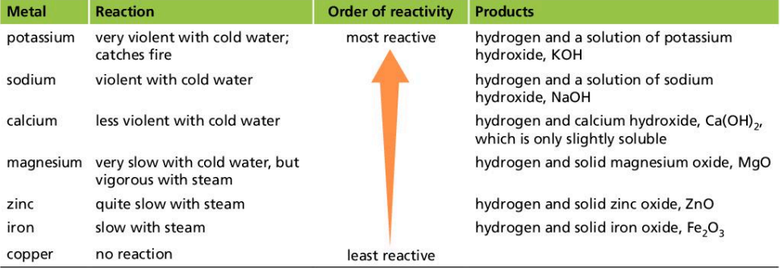
1. K , Na , Ca can react with cold water . 可以与冷水反应 ，反应变得不剧烈
2. Mg ,Zn ,Fe can react with steam
Mg(s) + H₂O(l) → MgO (s) + H₂(g)
2. Metal react with dilute hydrochloric acid
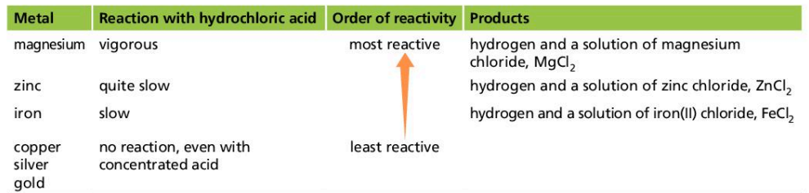
3. Metal react with oxygen
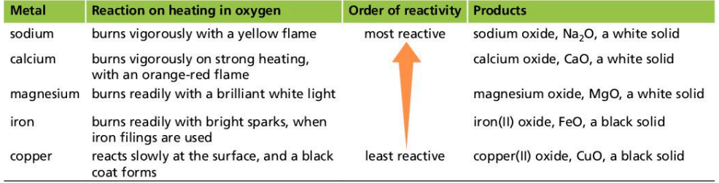

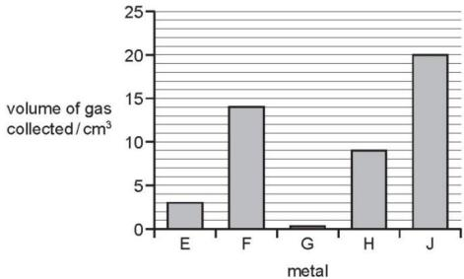
1. Samples of five different metals, E, F, G, H and J were reacted with dilute sulfuric acid using the apparatus shown.
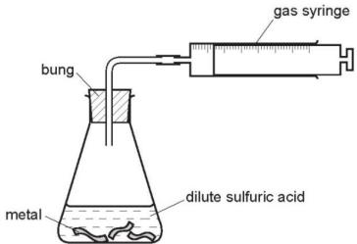

The volume of hydrogen gas collected after one minute was measured.
The results are shown on the bar chart.
What is the order of reactivity of the metals (most reactive first)? （ ）
A E,F,G,H,J
B G,E,H,F,J
C J,F,H,E,G
D J,H,G,F,E

2. Calcium reacts with cold water to produce hydrogen.
Lead reacts slowly when heated in air to form an oxide but has almost no reaction with steam.
Silver does not react with either air or water.
Zinc reacts when heated with steam to produce hydrogen.
What is the order of reactivity starting with the least reactive? （ ）
 | least reactive | most reactive
A | calcium | lead | zinc | silver
B | calcium | zinc | lead | silver
C | silver | lead | zinc | calcium
D | silver | zinc | lead | calcium

4. 从金属的置换反应来判断金属的reactivity series
Reactivity series: K , Na , Ca, Mg, Al, Zn, Fe , H ,Cu , Ag, Au
(Most reactive) (lest reactive)
Displacement reaction: 2 Al + Fe₂O₃ → 2Fe + Al₂O₃
2 Cu + AgNO₃ → 2Ag + Cu(NO₃)₂
The more reactive metal replaces the less reactive metal ion by losing electrons
更活泼的金属通过给电子的方式取代不活泼的金属
1. The results of two experiments are given.
1 Cobalt displaces manganese from an aqueous solution of a manganese salt.
2 Manganese displaces silver from an aqueous solution of a silver salt.
Three more experiments are carried out.
3 Cobalt is added to an aqueous solution of a silver salt.
4 Manganese is added to an aqueous solution of a cobalt salt.
5 Silver is added to an aqueous solution of a cobalt salt.
In which experiments does a reaction take place? （ ）
A 3 only B 3 and 4 C 4 and 5 D 5 only

2. Element Y reacts with copper(II) oxide to form copper.
Element Y will not react with zinc oxide. Copper has no reaction with zinc oxide.
What is the order of reactivity of these three elements, most reactive first?（ ）
A $Cu→Y→Zn$ B $Cu→Zn→Y$ C $Zn→Cu→Y$ D $Zn→Y→Cu$

6. 从金属活泼性来判断某金属的矿石不能被C还原。
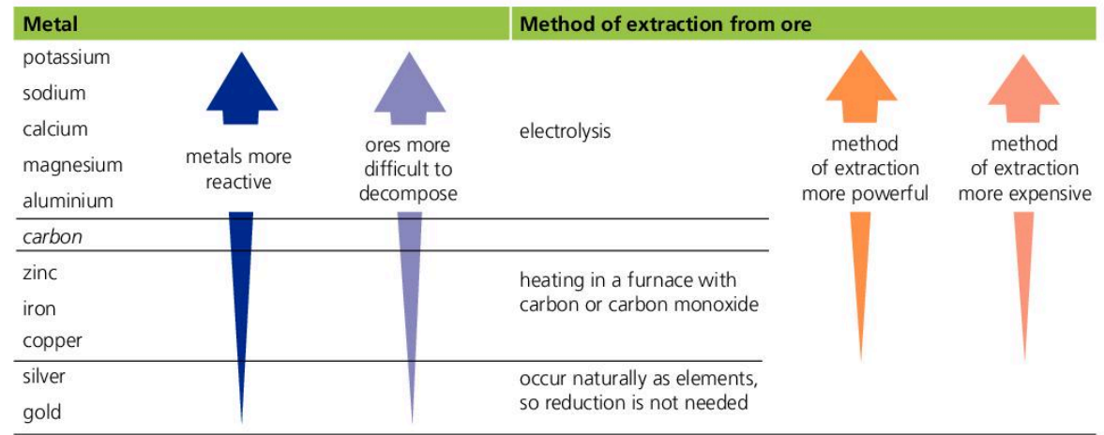
P, Na ,Ca, Mg , Al 比C 活泼无法用C还原， 而是得用电解方式分解
C 比 Zn, Fe , Cu 活泼. 可以用C在blast furnace 中还原。
1. Which statement about the extraction of iron from its ore is correct? （ ）
A Iron is more difficult to extract than zinc.
B Iron is more difficult to extract than copper.
C Iron is easy to extract because it is a transition metal.
D Iron cannot be extracted by reduction with carbon.

2. Many metals are extracted from their ores by heating the metal oxide with carbon.
Which metal cannot be extracted using this method? （ ）
A aluminium B copper C iron D zinc

3 . Which word equation represents a reaction which occurs? （ ）
A sodium oxide $​^{+}$ carbon $→$ sodium $​^{+}$ carbon dioxide
B sodium oxide $​^{+}$ iron $→$ sodium $​^{+}$ iron(II) oxide
C iron(II) oxide $​^{+}$ copper $→$ iron $​^{+}$ copper(II) oxide
D iron(III) oxide $​^{+}$ carbon $→$ iron $​^{+}$ carbon dioxide

7. 金属的应用与其性质的关系
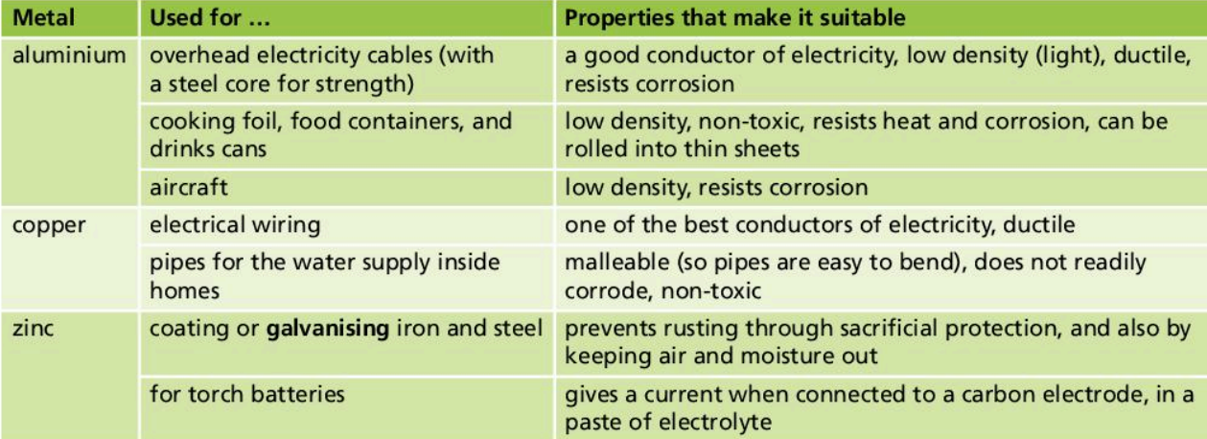
1. Which row shows uses of the metals listed? （ ）
 | aluminium | copper | mild steel
A | aircraft manufacture | food containers | cutlery
B | cutlery | electrical wiring | chemical plant
C | electrical wiring | aircraft manufacture | cooking utensils
D | food containers | cooking utensils | car bodies

2. Which statement about the uses of metals is not correct? （ ）
A Aluminium is used in aircraft because of its strength and good electrical conductivity.
B Copper is used in electrical wiring because of its good electrical conductivity.
C Stainless steel resists corrosion and is used to make cutlery.
D Transition elements are often used as catalysts.

3. Which statement about the uses of metals is correct? （ ）
A Aluminium is used in the manufacture of aircraft because of its strength and high density.
B Copper is used in electrical wiring because of its strength and high density.
C Mild steel is used in the manufacture of car bodies because of its strength and resistance to corrosion.
D Stainless steel is used in the construction of chemical plant because of its strength and resistance to corrosion.

8. Alloy的结构及其坚硬的原因
Alloy :mixture of a metal with at least one other element
合金是金属与其他元素的混合物 Harder and stronger
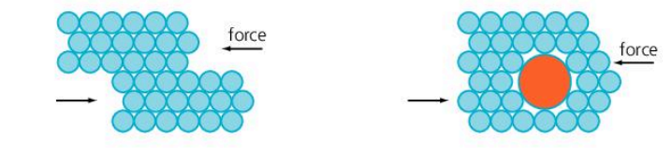
原因：When an alloy is made, new atoms enter the lattice.
The layers of metal ions cannot slide so easily. (金属离子层无法轻易移动)
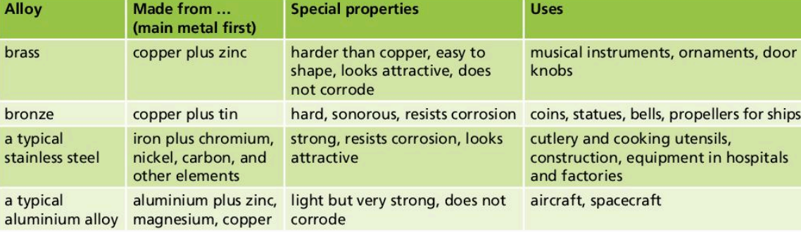
1. The diagrams show the structure of two substances used to make electrical conductors.
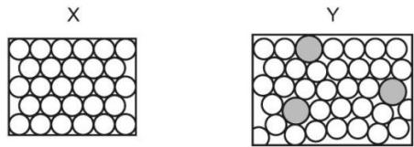
Which statement correctly describes X and Y? （ ）
A X is a pure metal and Y is a compound.
B X is a pure metal and Y is an alloy.
C X is a solid and Y is a liquid.
D X is harder and stronger than Y.

2. Which row describes the uses of mild steel and stainless steel? （ ）
 | mild steel | stainless steel
A | car bodies, cutlery | chemical plant, machinery
B | car bodies, machinery | chemical plant, cutlery
C | chemical plant, cutlery | car bodies, machinery
D | chemical plant, machinery | car bodies, cutlery

3. Stainless steel is an alloy of iron, carbon and other metals.
Which row is correct? （ ）
 | stainless steel is harder than pure iron | stainless steel resists corrosion better than pure iron
A | ✓ | ✓
B | ✓ | ×
C | × | ✓
D | × | ×

4. Which row describes the use of an alloy and the property upon which the use depends? （ ）
 | alloy | use | property
A | mild steel | cutlery | resistant to corrosion
B | mild steel | machinery | strong
C | stainless steel | cutlery | low density
D | stainless steel | machinery | good conductor of electricity

